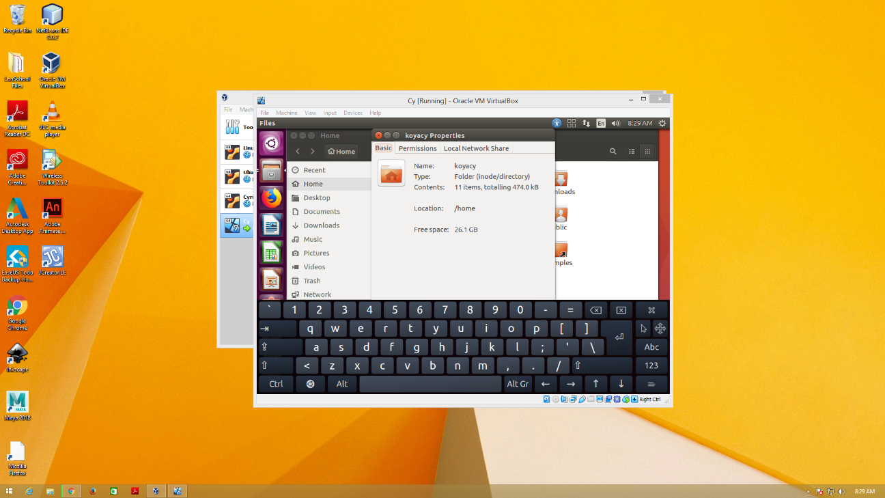Name: Cyrille Leigh Evan M. Isayas BSIT-301